**Lab Introduction:**

In this lab we’ll be learning the basics of Router and Repeater and uses of them in LANs using a network simulation tool, Cisco Packet Tracer.

**Objectives:**

* To learn what a Router and a repeater is
* How a Router and a repeater works
* Where and why a Router is needed
* Where and why a Repeater is needed

**Index**

|  |  |  |
| --- | --- | --- |
| Experiment No. | Experiment Title | Page |
| 01 | Introduction with Router using Cisco Packet Tracer | 2 |
| 02 | Introduction with Repeater using Cisco Packet Tracer | 7 |

**Experiment No.: 1**

**Experiment Title:** Introduction with Router using Cisco Packet Tracer

**Objectives:**

* To learn what a Router is
* How a Router works
* Where and why a Router is needed

**Discussion:**

A Router, an inevitable device for the internet, is a networking device that forwards data packets between computer networks.

* It connects two or more LANs
* It is a layer 3(i.e. Network layer) device
* It has a memory and stores routing table

**Methodology:**

* Create a New Project.
* Create the basic Network topology.
* Configuration of the Network Nodes.
* Choose the Statistics.
* Run the Simulation.
* Analysis of the Results.

**Working procedure:**

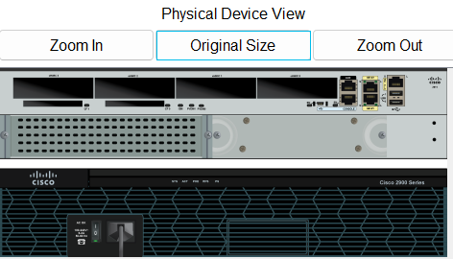

Fig 1.1: Physical rear view of a 2911 Router

1. **Connecting two LANs of different IP schemes with a Router**

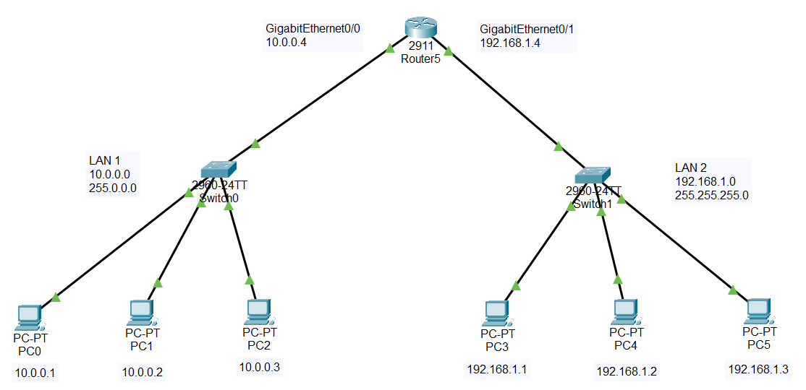

Fig 1.2: Two labeled LANs of different IP schemes connected by a Router in CPT

* 1. Configure PC0, PC1, PC2 with the following IP addresses and Subnet Masks

|  |  |  |  |
| --- | --- | --- | --- |
| **Host** | **IP Address** | **Subnet Mask** | **Default Gateway** |
| PC0 | 10.0.0.1 | 255.0.0.0 | 10.0.0.4 |
| PC1 | 10.0.0.2 | 255.0.0.0 | 10.0.0.4 |
| PC2 | 10.0.0.3 | 255.0.0.0 | 10.0.0.4 |

* 1. Configure PC3, PC4, PC5 with the following IP addresses and Subnet Masks

|  |  |  |  |
| --- | --- | --- | --- |
| Host | **IP Address** | **Subnet Mask** | **Default Gateway** |
| PC3 | 192.168.1.1 | 255.255.255.0 | 192.168.1.4 |
| PC4 | 192.168.1.2 | 255.255.255.0 | 192.168.1.4 |
| PC5 | 192.168.1.3 | 255.255.255.0 | 192.168.1.4 |

* 1. Connection tests across PCs in a single LAN

Ping two PCs by there IP addresses from another PC within a LAN, one after another. If connection is there, four replies will come.

Do the same for the second LAN.

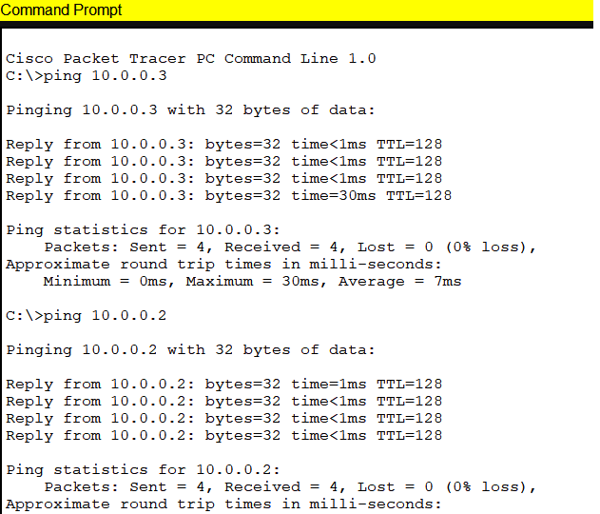

Fig 1.3: Pinging PC2 and PC1 from PC0

1.4. Connecting LANs with a Router

A. Connecting LAN1 with the Router by the GigabitEthernet0/0 interface

B. Connecting LAN2 with the Router by the GigabitEthernet0/1 interface

C. Giving the interfaces an IP address and a Subnet Mask of the same scheme

|  |  |  |
| --- | --- | --- |
| **Interface** | **IP address** | **Subnet Mask** |
| GigabitEthernet0/0 | 10.0.0.4 | 255.0.0.0 |
| GigabitEthernet0/1 | 192.168.1.4 | 255.255.255.0 |

1. Check “On” in the port status for each interface in the

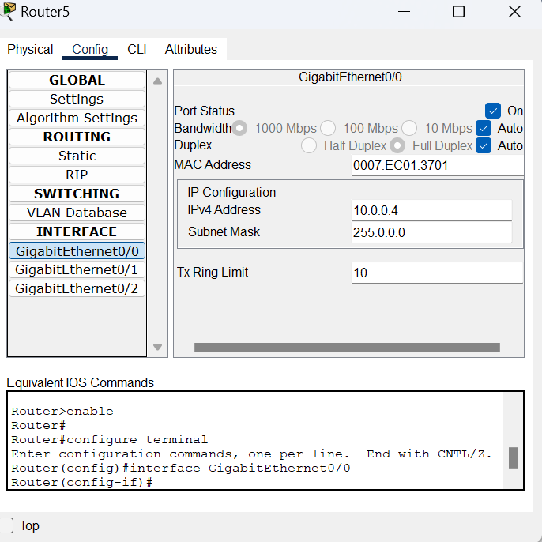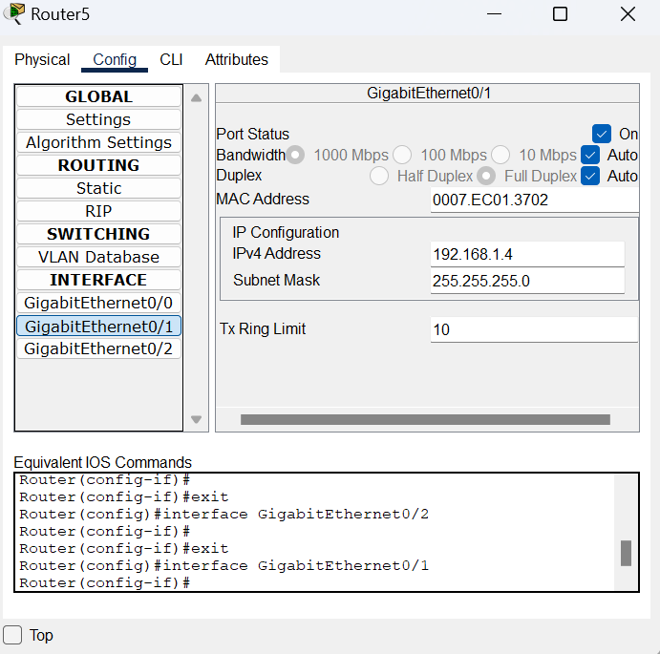

Fig 1.4: Configuring GigabitEthernet0/0 and GigabitEthernet0/1 of the Router

1. **Sending data across LANs**

For the first time communication, 1 packet may be lost, but from then on, data will be transmitted with 0% loss.

Also, if observed in simulation mode, for the first time communication, switch will be broadcasting data packets as the IP address of the Router hasn’t been stored.

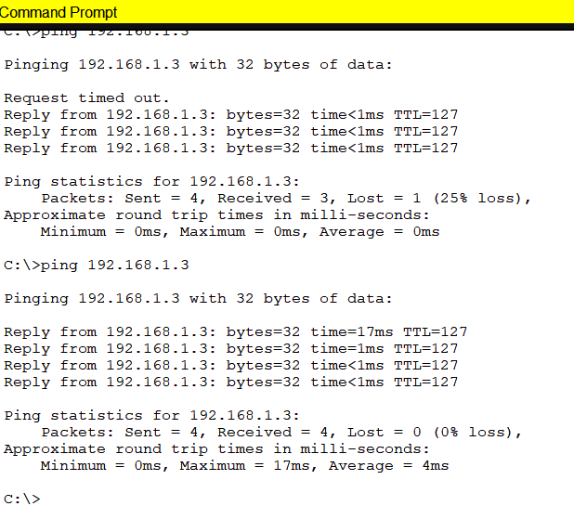

Fig 1.5: Pinging PC5 from PC0

1. **Simulation:**

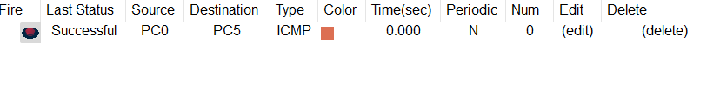

Fig 1.6: Successful packets travel across PCs

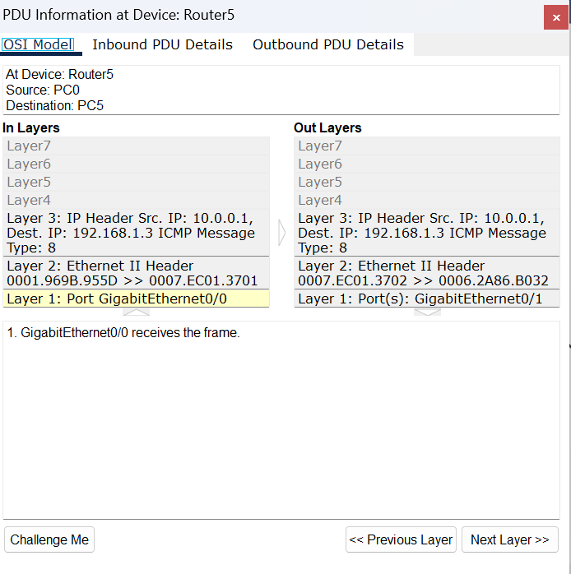

Fig 1.7: PDU information at Router5

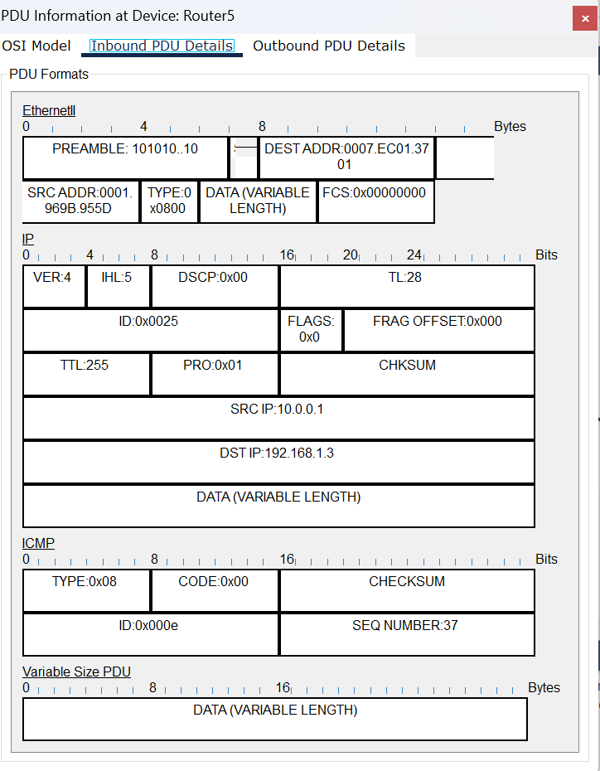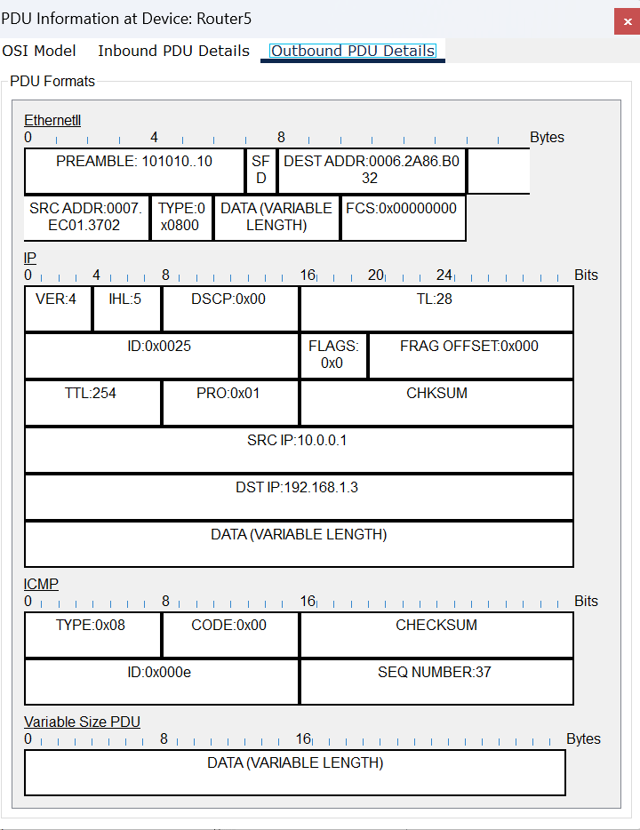

Fig 1.8: Inbound and Outbound PDU details at Router5

**Conclusion:**

* A Router is needed to create an inter LAN.
* A Router has a memory and it stores routing table
* A Router is a layer 3 device

**Experiment No.: 2**

**Experiment Title:** Introduction with Repeater using Cisco Packet Tracer

**Objectives:**

* To learn what a Repeater is
* How a Repeater works
* Where and why a Repeater is needed

**Discussion:**

Signals traveling a long distance tend to get weak or corrupted. For this we use a repeater to generate the same signal midway.

* A Repeater generates the signal over the same network
* It is a layer 1(i.e. Physical layer) device
* It does not amplify the signal
* It is a two port device

**Methodology:**

* Create a New Project.
* Create the basic Network topology.
* Configuration of the Network Nodes.
* Choose the Statistics.
* Run the Simulation.
* Analysis of the Results.

**Working procedure:**

1. **Connecting two LANs of the same IP scheme with a Router**

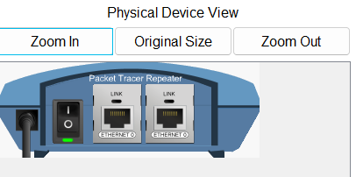

Fig 2.1: Physical rear view of a repeater

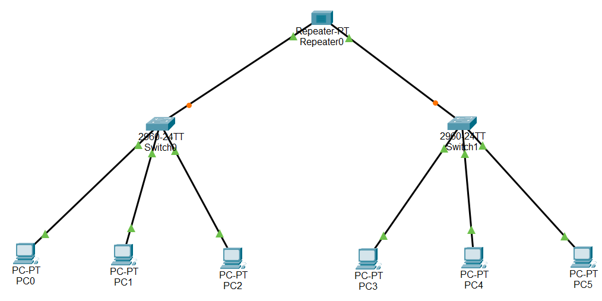

Fig 2.2: Two LANs of same IP schemes connected through a repeater in CPT

* 1. Configure PC0, PC1, PC2 with the following IP addresses and Subnet Masks

|  |  |  |
| --- | --- | --- |
| **Host** | **IP Address** | **Subnet Mask** |
| PC0 | 10.0.0.1 | 255.0.0.0 |
| PC1 | 10.0.0.2 | 255.0.0.0 |
| PC2 | 10.0.0.3 | 255.0.0.0 |

* 1. Configure PC3, PC4, PC5 with the following IP addresses and Subnet Masks

|  |  |  |
| --- | --- | --- |
| Host | **IP Address** | **Subnet Mask** |
| PC3 | 10.0.0.4 | 255.0.0.0 |
| PC4 | 10.0.0.5 | 255.0.0.0 |
| PC5 | 10.0.0.6 | 255.0.0.0 |

* 1. Connection tests across PCs in a single LAN

Ping two PCs by there IP addresses from another PC within a LAN, one after another. If connection is there, four replies will come.

Do the same for the second LAN.



Fig 2.3: Pinging PC2 and PC1 from PC0

* 1. Connecting two LANs via the two switches with straight through Ethernet cables by the two interfaces of the Repeater.

1. **Sending data across LANs**

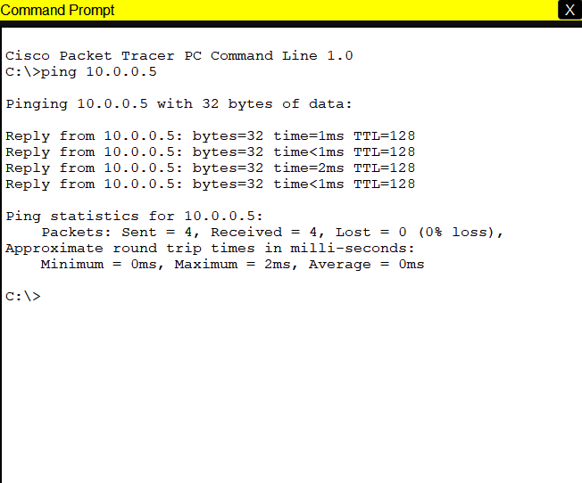

Fig 2.4: Pinging PC5 from PC0

1. **Simulation:**



Fig 2.5: Successful packets travel across PCs

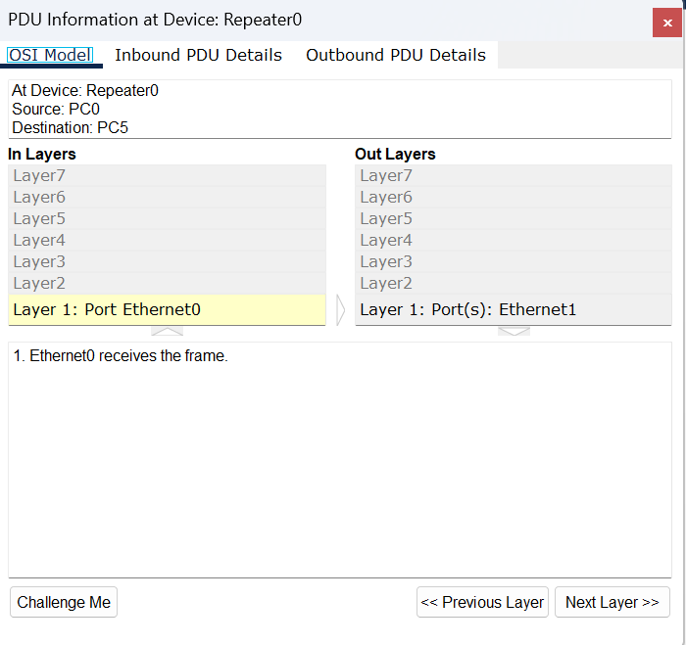

Fig 2.6: PDU information at Repeater

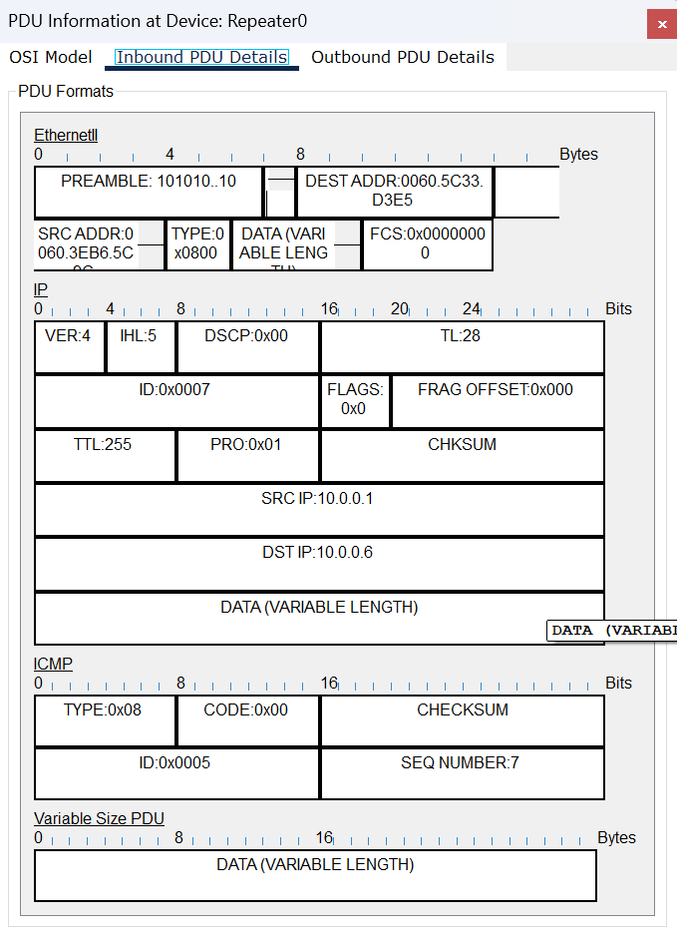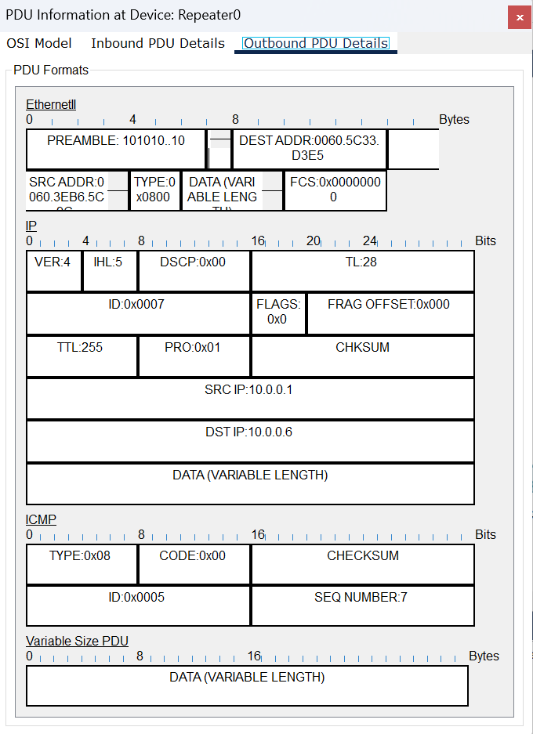

Fig 2.7: Inbound and Outbound PDU details at Repeater

**Conclusion:**

* A Router is a layer 1 device
* A Repeater is needed to regenerate signal traveling over long distances.
* A Repeater does not amplify the signal, only regenerates the same signal over the same network.

**Lab Conclusion:**

From this lab we got to know about,

* The basics of Router
* A Router is a layer 3 device, therefore, it operates at the Network layer of the OSI model
* A Router is an intelligent device as it has a a memory where it stores the routing table
* The basics of Repeater
* A Repeater is a layer 1 device. Therefore, it operates at the Physical layer of the OSI model.
* A Repeater is a 2 port device as it generally has only 2 ports
* A Repeater only regenerates the received-signal and does not amplify it
* A repeater works over the same LAN
* Use of Router
* A Router is used to create an inter-LAN(Local Area Network)
* A Router can inter-connect two LANs of different IP schemes
* Use of Repeater
* A repeater is used to regenerate a signal that needs to travel a long distance over the same network; for without it(repeater), the signal may get weak or corrupted.